DATABASE MANAGEMENT LAB Report
Submitted in partial fulfilment of the requirement of the degree of BACHELORS OF TECHNOLOGY
to
K.R Mangalam University



Submitted by: Submitted to
RADHIKA Ms. Mansi Kajal
(2401010094) (Assistant Professor)

Department of Computer Science and Engineering School of Engineering and Technology
K.R Mangalam University, Gurugram- 122001, India SESSION – 2025-2026

DBMS Lab Assignment-6
Updating Records (Client_master Table)
(Exercise on updating records in table)
Create Client_master with the following fields (ClientNO, Name, Address, City, State, bal_due)
- Insert five records into the Client_master table.
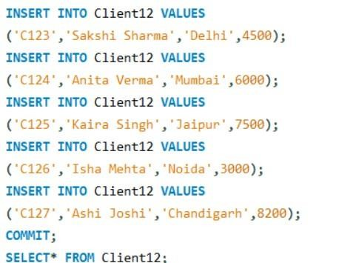

OUTPUT :
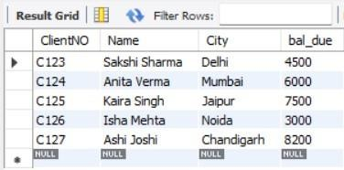

- Find the names of clients whose bal_due > 5000.
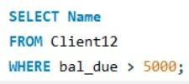

OUTPUT :
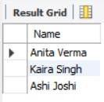

- Change the bal_due of ClientNO "C123" to Rs. 5100.
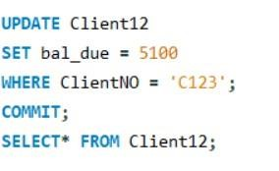

OUTPUT :
